Experiment: 5
Simulation and Throughput Analysis of LTE-Advanced Carrier Aggregation

Objective – 1: Model One Component Carrier

clc;
clear;
close all;
% System parameters
BWcc = 20; % Bandwidth per component carrier (MHz)
SE = 4; % Spectral efficiency (bits/s/Hz)
CC = [1 2 3]; % Number of component carriers
% Calculate aggregated bandwidth and throughput
AggBW = BWcc .* CC;
Throughput = AggBW .* SE;
% Display results
disp('CC Aggregated BW (MHz) Estimated Throughput (Mbps)');
disp([CC' AggBW' Throughput']);
% Plot throughput
figure;
bar(CC, Throughput);
grid on;
xlabel('Number of Aggregated Component Carriers');
ylabel('Estimated Throughput (Mbps)');
title('LTE-Advanced Carrier Aggregation Throughput');
% Display values above bars
for k = 1:length(CC)
text(CC(k), Throughput(k), sprintf(' %d Mbps', Throughput(k)), ...
'HorizontalAlignment', 'center', ...
'VerticalAlignment', 'bottom');
End
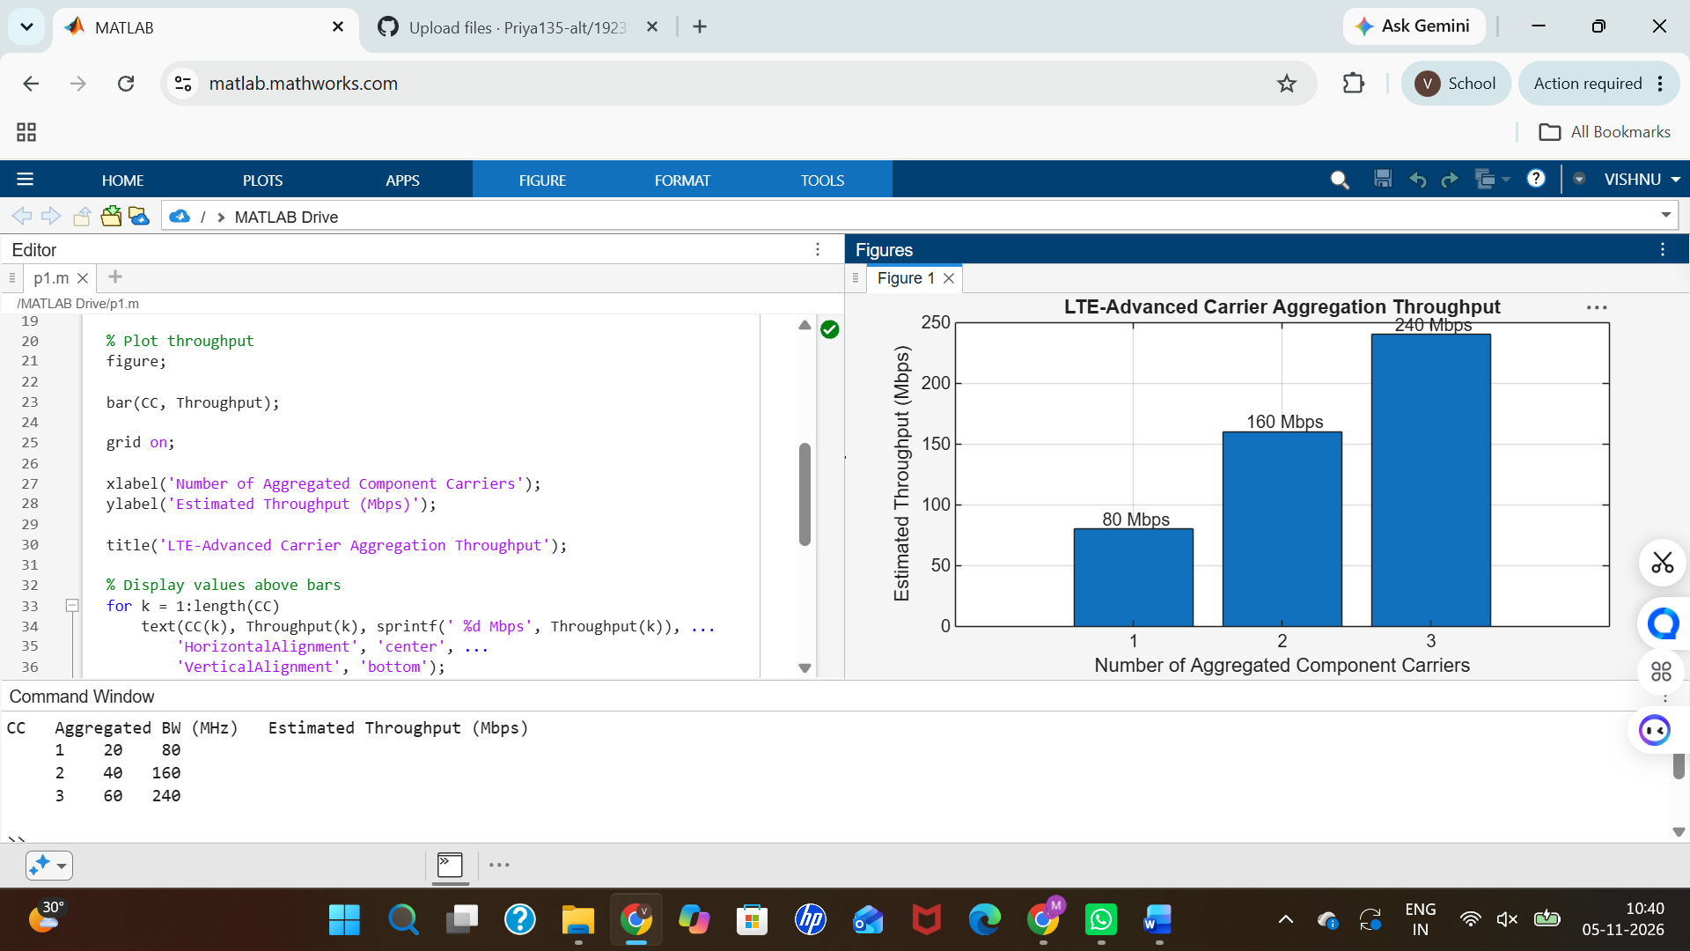
Objective – 2: Extend to Multiple Aggregated Component Carriers

clc;
clear;
close all;
% System parameters
BWcc = 20; % MHz per component carrier
SE = 4; % Spectral efficiency (bits/s/Hz)
CC = [1 2 3]; % Number of component carriers
% Calculate aggregated bandwidth and throughput
AggBW = BWcc .* CC;
Throughput = AggBW .* SE;
% Display results
disp('CC Aggregated BW (MHz) Estimated Throughput (Mbps)');
disp([CC' AggBW' Throughput']);
% Plot throughput
figure;
bar(CC, Throughput);
grid on;
xlabel('Number of Aggregated Component Carriers');
ylabel('Estimated Throughput (Mbps)');
title('LTE-Advanced Carrier Aggregation Throughput');

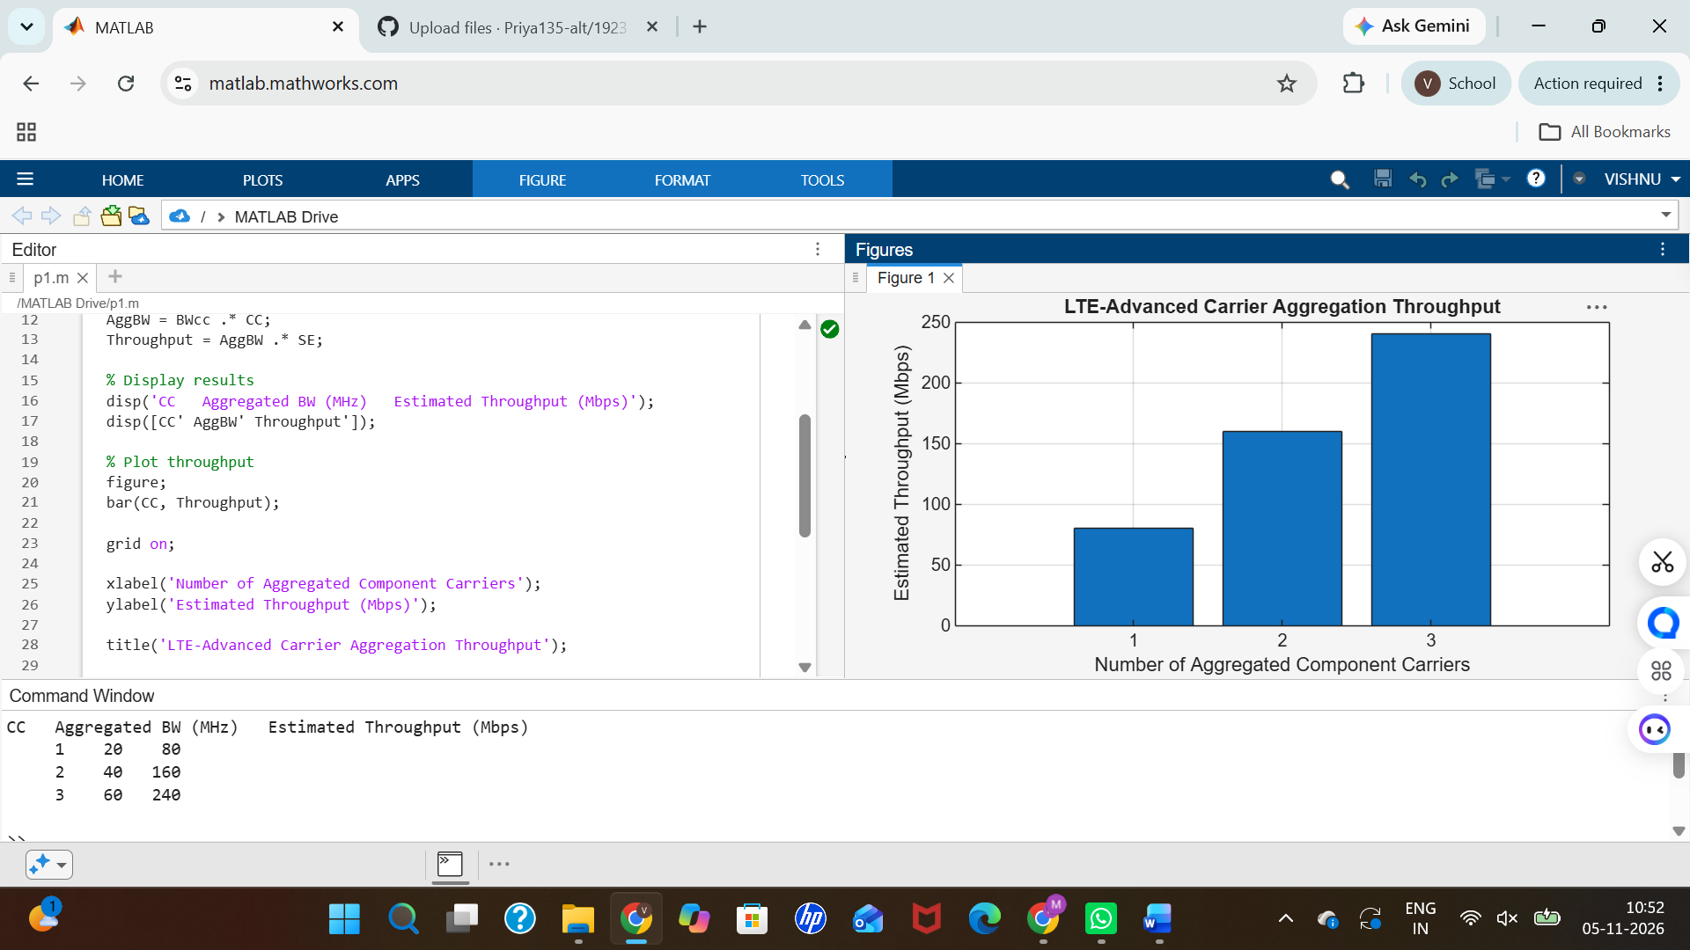
Objective – 3: Compare Estimated Throughput for Different Carrier Bandwidths Procedure
clc;
clear;
close all;
% Carrier bandwidths in MHz
BW = [5 10 15 20];
% Spectral efficiency
SE = 4; % bits/s/Hz
% Calculate estimated throughput
TP = BW .* SE;
% Display results
disp('Bandwidth (MHz) Throughput (Mbps)');
disp([BW' TP']);
% Plot throughput versus bandwidth
figure;
plot(BW, TP, 'o-', 'LineWidth', 2);
grid on;
xlabel('Carrier Bandwidth (MHz)');
ylabel('Estimated Throughput (Mbps)');
title('Throughput vs Component Carrier Bandwidth');


